Univariate treatment of the variable : Duration
Duration is a continuous quantitative variable (data are grouped into classes)
Duration | Absolute frequency | Relative frequency | Cumulative Absolute frequency | Cumulative Relative frequency | Width | Center | Heights
< 15 | 2 | 4% | 2 | 4% | 15 | 7.5 | 0.133
15 - 30 | 3 | 6% | 5 | 10% | 15 | 22.5 | 0.2
30 – 60 | 5 | 10% | 10 | 20% | 30 | 45 | 0.166
60 – 90 | 25 | 50% | 35 | 70% | 30 | 75 | 0.833
>= 90 | 15 | 30% | 50 | 100% | 30 | 105 | 0.5
Total | 50 | 100%

Modal class: [60 ; 90[ mode = 60 + 30 x (0.667/ (0.333 + 0.667)) = 80.01 minutes
Mean = 75.15
Standard deviation = 26.6008
Coefficient of variation = 35.39694% (> 15%)
Pearson coefficient = -0.1827013 < 0
The first quartile belongs to [60 ; 90[ q1 = 63
The median belongs to [60 ; 90 [ med = 78
The third quartile belongs to >= 90 (by convention [90 ; 120[) q3 = 95
Interquartile range = 32
Relative Interquartile range = 41.02564 % (> 15%)
Yule and Kendall coefficient = 0.0625 > 0
Lower whsiker (box plot) : 15
Upper whsiker (box plot) : 120 = max
- The class < 15 is considered as an extreme class

Histogram
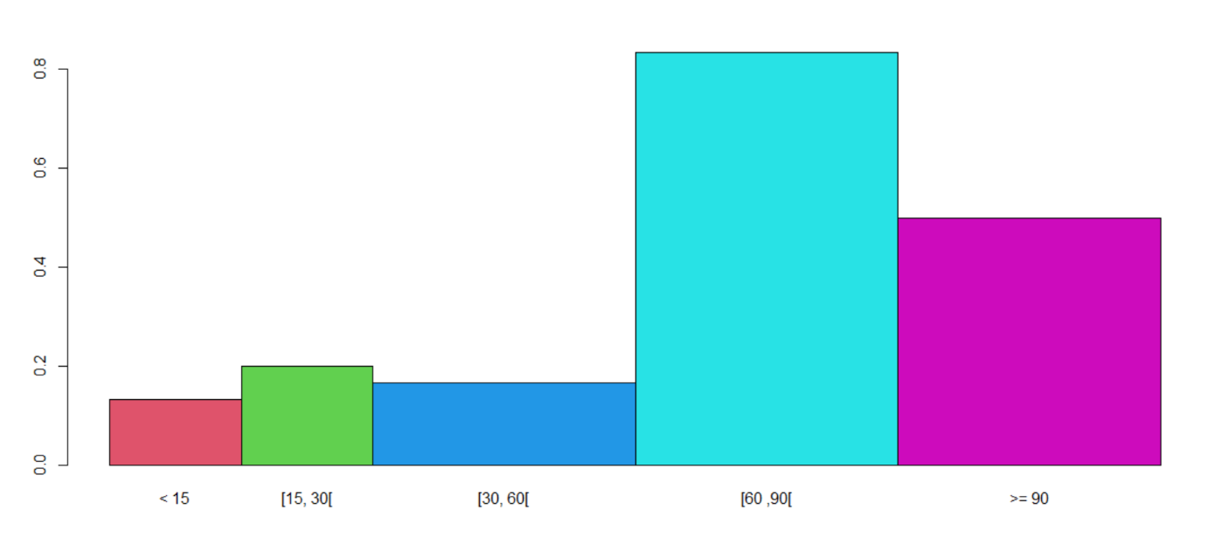

Increasing cumulative frequency curve:

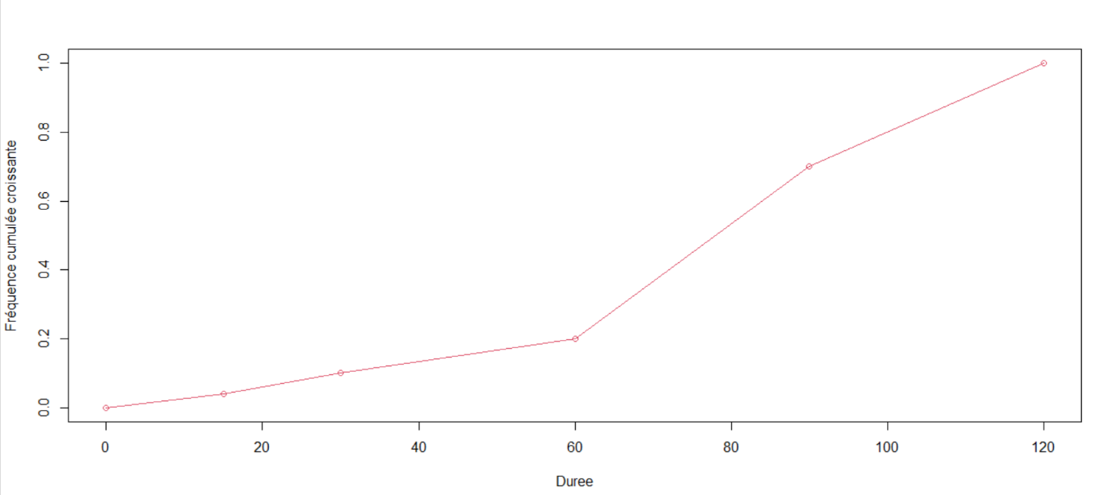

Univariate treatment of the variable: Number of beverages
Number of beverages is a discrete quantitative variable
 | Absolute frequency | Relative frequency | Cumulative Absolute frequency | Cumulative Relative frequency
0 | 27 | 54% | 27 | 54%
1 | 16 | 32% | 43 | 86%
2 | 5 | 10% | 48 | 96%
3 | 2 | 4% | 50 | 100%
Total | 50 | 100%

Mode = 0 / q1 = med = 0 / q3 = 1 / Interquartile range = 1 – 0 = 1
Lower whisker (box plot) : 0
Upper whsiker (box plot) : 2 la modalité 3 est aberrante
Min = 0 / Max = 3 / Range = 3 - 0 = 3
Mean = 0.64 / Standard deviation = 0.8187796 / coefficient of variation = 78.16511% (> 15%)
Pearson Coefficient = 0.7816511 > 0
Yule and Kendall Coefficient = 1 > 0
Graphical representation of data:
Bar chart
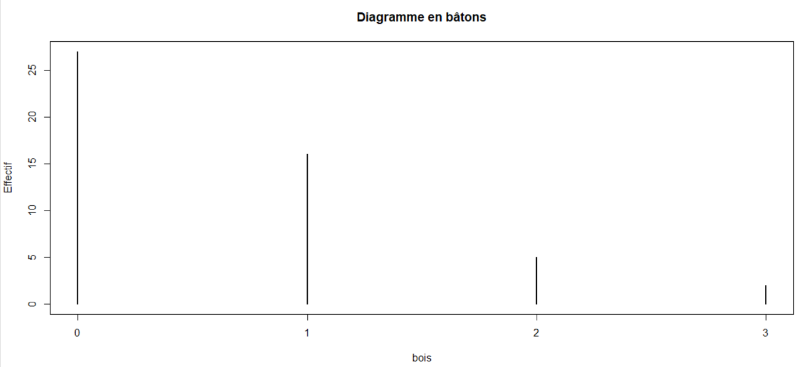

Box plot :

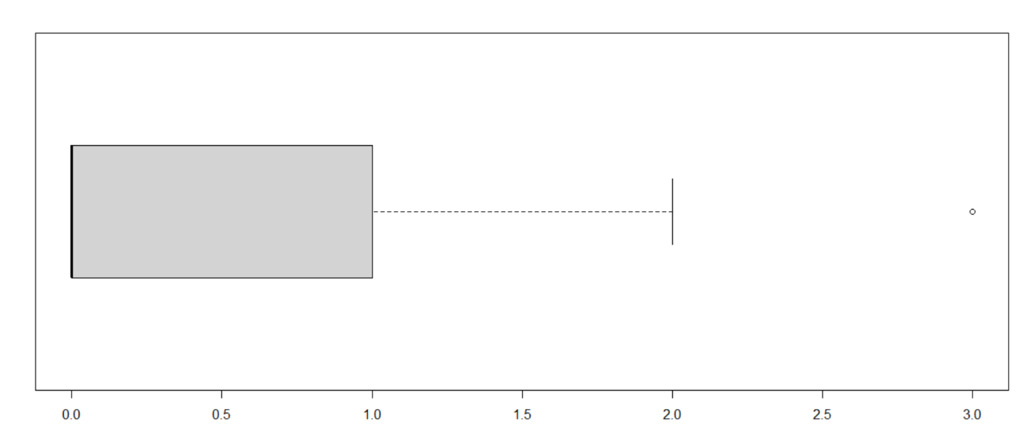

Curve of increasing cumulative frequencies

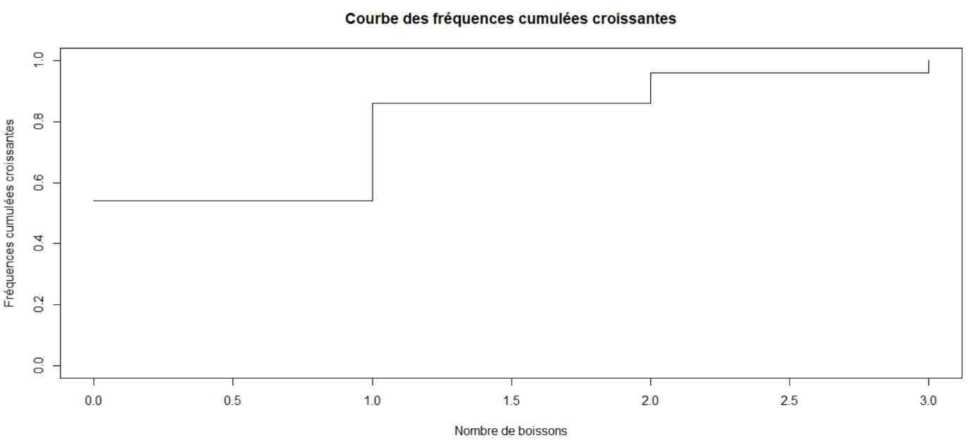

Univariate treatment of the variable: Age
Age is a continuous quantitative variable (data are grouped into classes)
Duration | Absolute frequency | Relative frequency | Cumulative Absolute frequency | Cumulative Relative frequency | Width | Center | Heights
< 24 | 2 | 4% | 2 | 4% | 6 | 21 | 0.33
24 - 30 | 2 | 4% | 4 | 8% | 6 | 27 | 0.33
30 – 45 | 4 | 8% | 8 | 16% | 15 | 37.5 | 0.26
45 – 65 | 18 | 36% | 26 | 52% | 20 | 55 | 0.9
>= 65 | 24 | 48% | 50 | 100% | 20 | 75 | 1.2
Total | 50 | 100%

Modal class: >= 65 mode = 65 + 20 x (0.3/ (0.3 + 1.2)) = 69 years old
Mean = 60.72
Standard deviation = 16.1673
Coefficient of variation = 26.62599 % (> 15%)
Pearson coefficent = -0.5121449 < 0
The first quartile belongs to [45 ; 65[ q1 = 50
The median belongs to [45 ; 65[ med = 63.88889
The third quartile belongs to >= 65 (by convention [65 ; 85[) q3 = 74.58333
Interquartile range = 24.58333
Relative interquartile coefficient = 0.3847825 (> 15%)
Yule and Kendall coefficient = -0.1299437 < 0
Lower whisker (box plot) : 18 = min
Upper whisker (box plot) : 85 = max
- No extreme class

Histogram
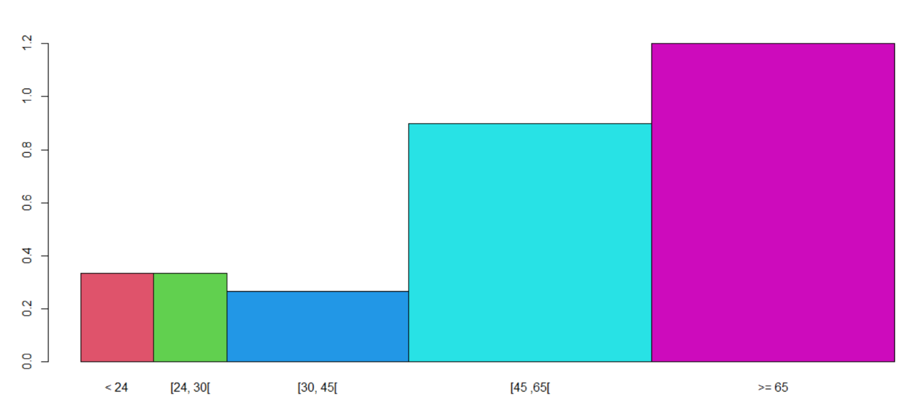

Increasing cumulative frequency curve:

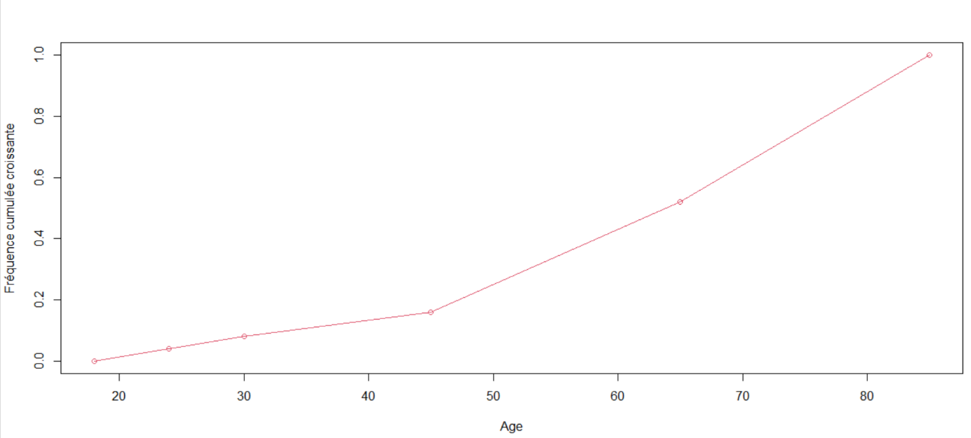

Univariate treatment of the variable: Level of satisfaction of the exhibition
Level of satisfaction of the exhibition is a discrete quantitative variable
Exhibition  Satisfaction | Absolute frequency | Relative frequency | Cumulative Absolute frequency | Cumulative Relative frequency
0 | 1 | 2% | 1 | 2%
1 | 1 | 2% | 2 | 4%
2 | 2 | 4% | 4 | 8%
3 | 30 | 60% | 34 | 68%
4 | 16 | 32% | 50 | 100%
Total | 50 | 100%

Mode = 3 / q1 = med = 3 / q3 = 4 / Interquartile range = 4 – 3 = 1
Lower whisker (box plot) : 2 0 are 1 are extreme values
Upper whisker (box plot) : 4
Min = 0 / Max = 4 / Range = 4-0 = 4
Mean = 3.18 / Standard deviation = 0.7665507 / coefficient of variation = 24.10537% (> 15%)
Pearson Coefficient = 0.2348181 > 0
Yule and Kendall Coefficient = 1 > 0
Graphical representation of the data:
Bar chart
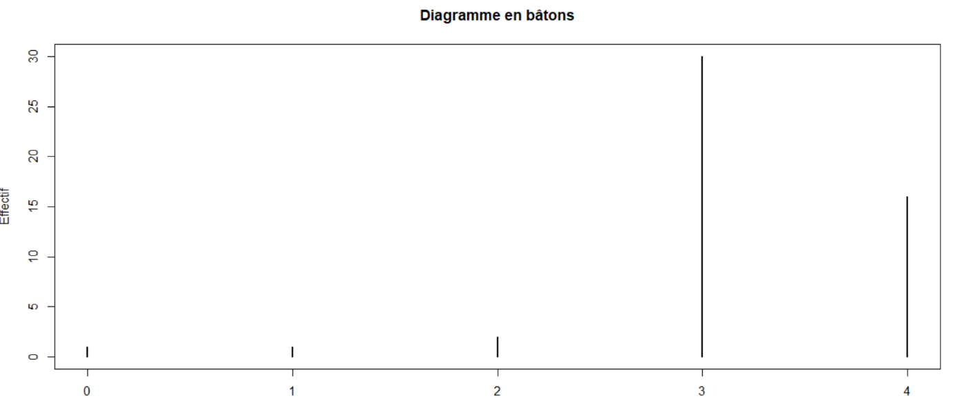

Box plot

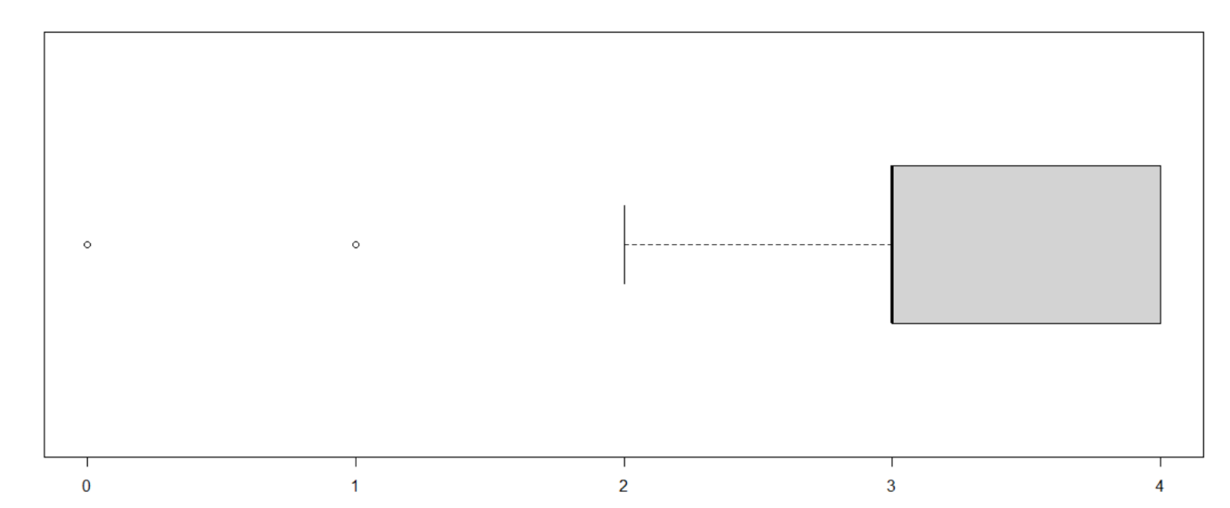

Curve of increasing cumulative frequencies

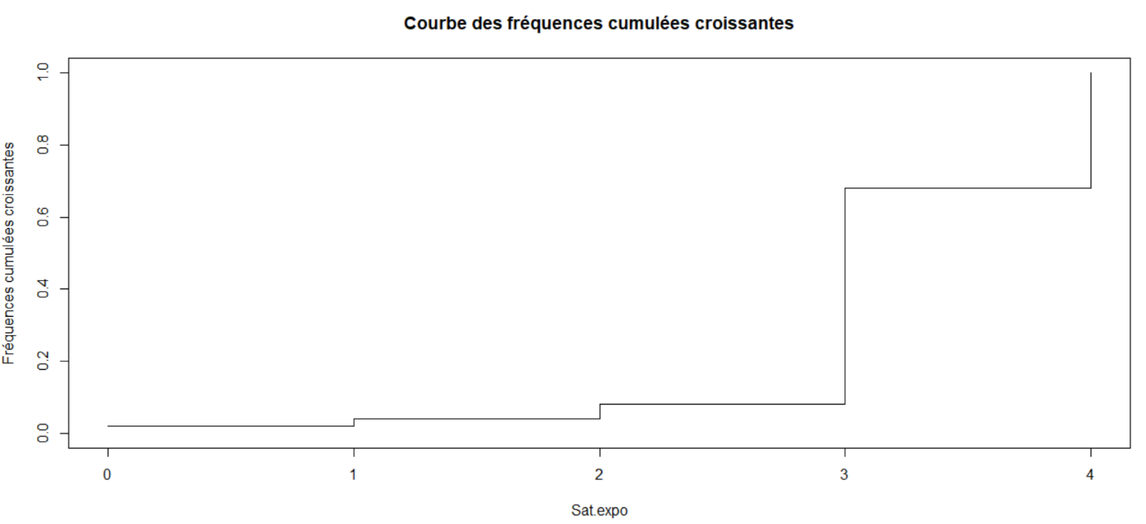

Univariate treatment of the variable: Level of satisfaction of the cafeteria
Level of satisfaction of the cafeteria is a discrete quantitative variable
Cafeteria  Satisfaction | Absolute frequency | Relative frequency | Cumulative Absolute frequency | Cumulative Relative frequency
0 | 24 | 48% | 24 | 48%
1 | 17 | 34% | 41 | 82%
2 | 6 | 12% | 47 | 94%
3 | 2 | 4% | 49 | 98%
4 | 1 | 2% | 50 | 100%
Total | 50 | 100%

Mode = 0 / q1 = 0 / med = q3 = 1 / Interquartile range = 1 – 0 = 1
Lower whisker (box plot) : 0
Upper whisker (box plot) : 2 3 and 4 are extreme values
Min = 0 / Max = 4 / Range = 4-0 = 4
Mean = 0.78 / Standard deviation = 0.9442457 / coefficient of variation = 121% (> 15%)
Pearson Coefficient = 0.8260562 > 0
Yule and Kendall Coefficient = -1 < 0
Graphical representation of the data:
Bar chart
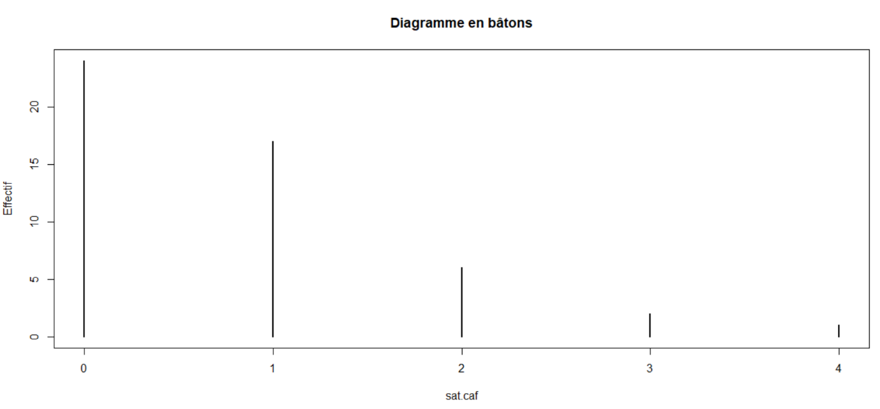

Box plot

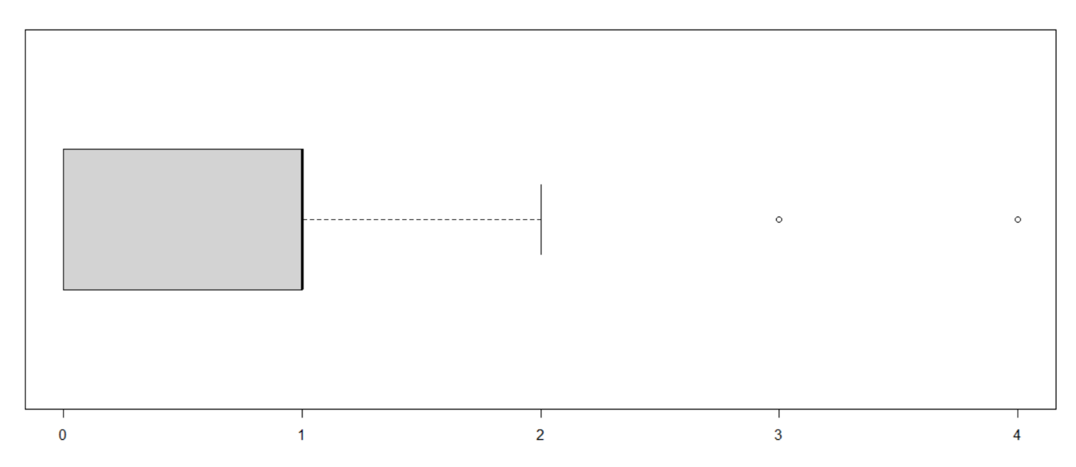

Curve of increasing cumulative frequencies

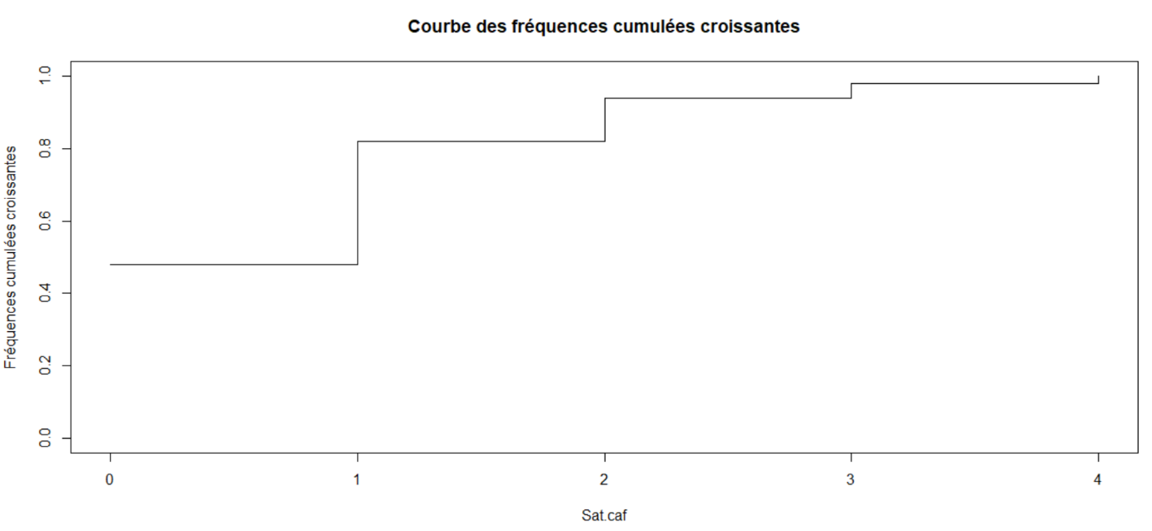

Univariate treatment of the variable: Attendance
Attendance is an ordinal qualitative variable
Attendance | Absolute frequency | Relative frequency | Cumulative Absolute frequency | Cumulative Relative frequency
Ra | 15 | 30% | 15 | 30%
Oc | 25 | 50% | 40 | 80%
Re | 10 | 20% | 50 | 100%
Total | 50 | 100%

Mode = ‘Oc’
Graphical representation of data

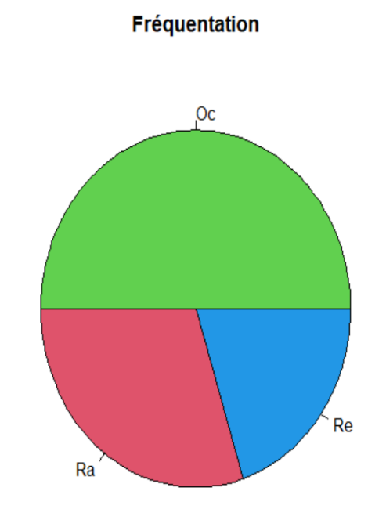

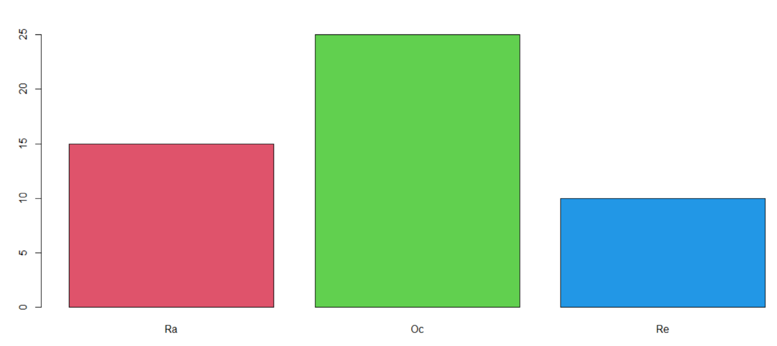
Univariate treatment of the variable: Means of Transport

Means of transport is a nominal qualitative variable

Transport | Absolute frequency | Relative frequency
A | 4 | 8%
P | 7 | 14%
TC | 18 | 36%
V | 19 | 38%
Ve | 2 | 4%
Total | 50 | 100%

Mode = ‘V’
Graphical representation of data
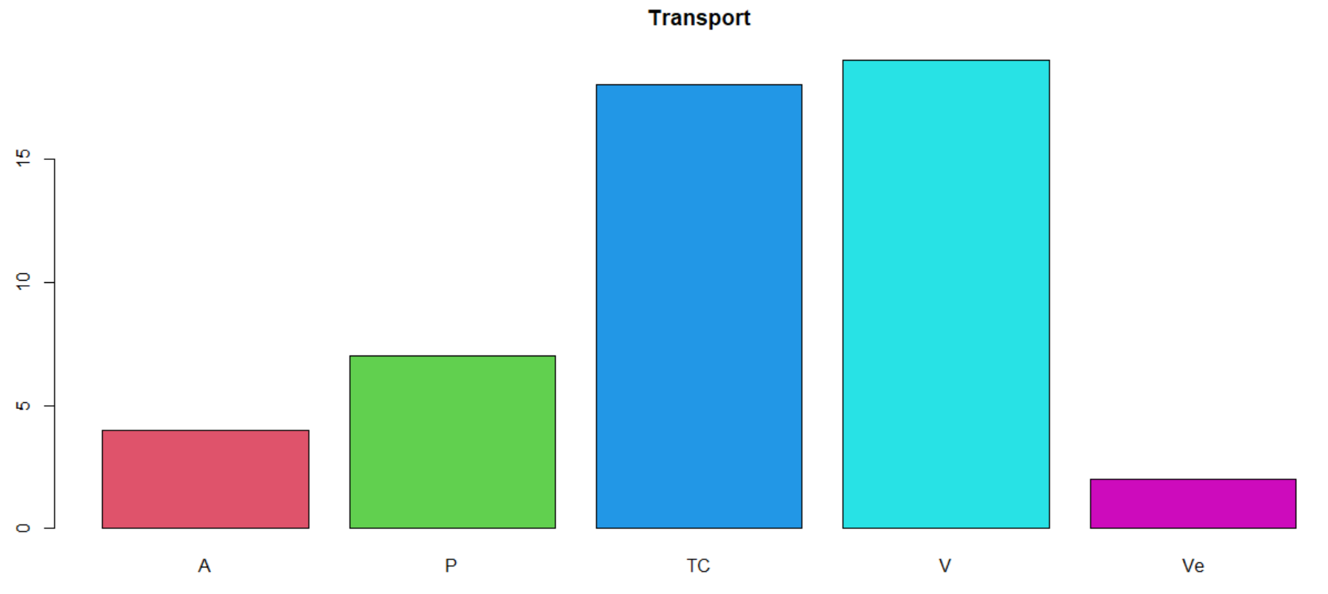
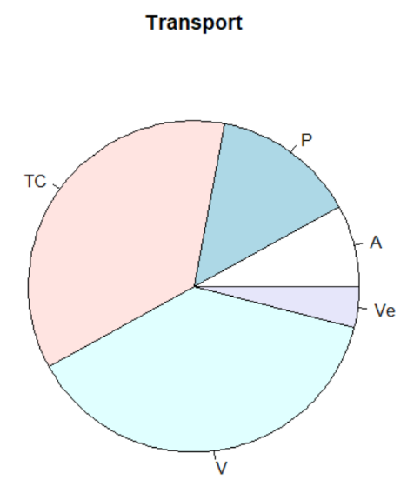
Univariate treatment of the variable: City
City is a nominal qualitative variable
Summary of data in a statistic table
City | Absolute frequency | Relative frequency
E | 18 | 36%
R | 32 | 64%
Total | 50 | 100%

Mode = ‘R’
Graphical representation of data

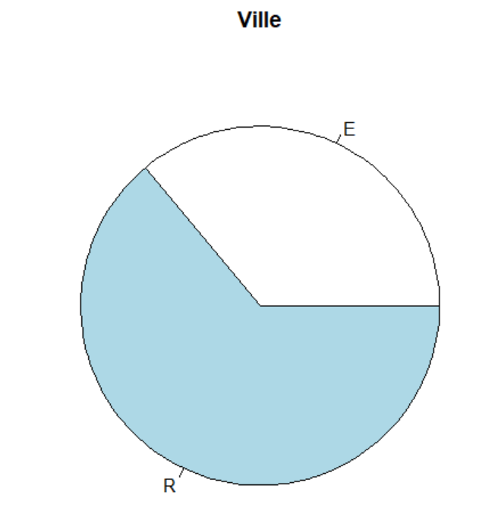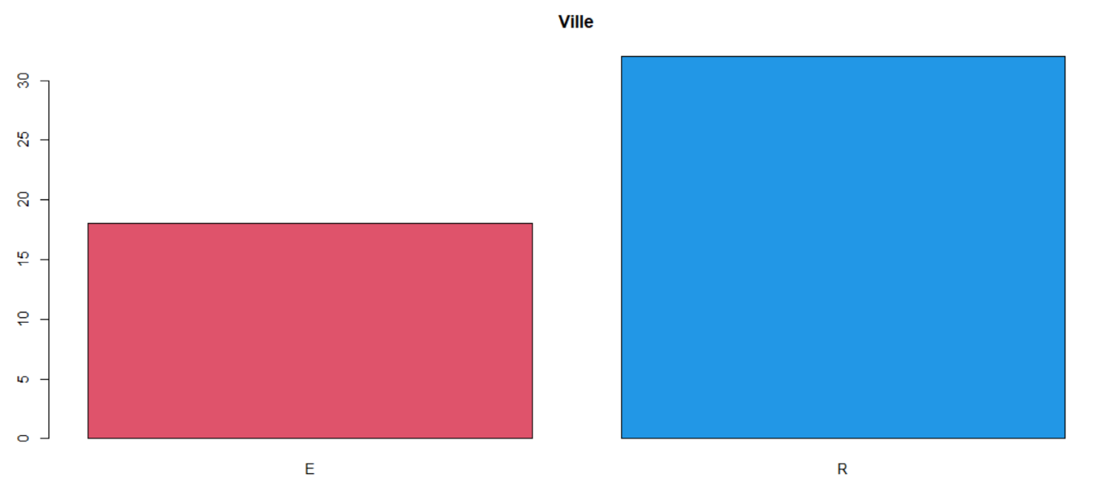

Study of the link between the level of satisfaction of the cafeteria and the level of satisfcation of the exhibition
Both variables are quantitative and the data are presented in a raw state
- Covariance = -0.06163265 < 0 (the data for the two variables vary in the opposite direction)
- Correlation = -0.08344706 (the coefficient is non-zero so we can deduce that there is a link between the two variables. However, this coefficient is close to zero which implies that the intensity of the linear link between the two variables is very weak)
Scatter plot :
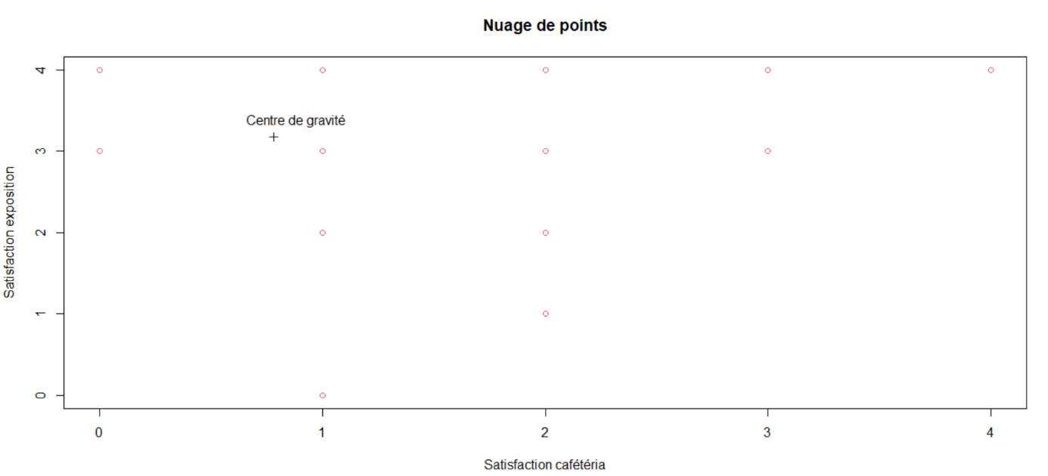
Study of the link between the level of satisfaction of the cafeteria and the number of beverages ordered during the visit

Both variables are quantitative and the data are presented in a raw state
- Covariance = 0.4702041 > 0 (the data for both variables vary in the same direction)
- Correlation = 0.5960195 (the coefficient is non-zero so we can deduce that there is a link between the data of the two variables. In addition, the coefficient belongs to [0.5 ; 0.7[which implies that the intensity of the linear link between the data of the two variables is moderate)
Scatter plot
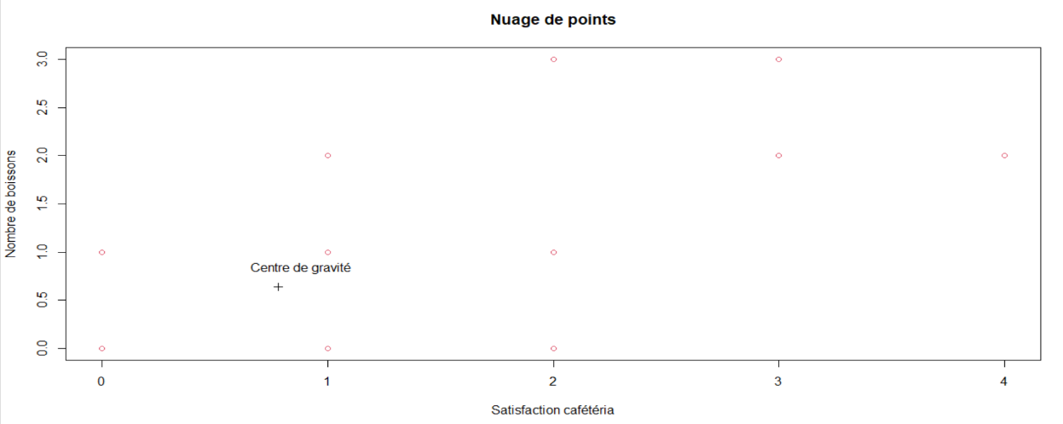
Study of the link between the age of visitors and the time they spent at the exhibition

Age | Duration | < 15 | [15 ; 30[ | [30 ; 60[ | [60 ; 90[ | >= 90
< 24 |  | 1 | 1 | 0 | 0 | 0
[24 ; 30[ |  | 1 | 1 | 0 | 0 | 0
[30 ; 45[ |  | 0 | 1 | 2 | 0 | 1
[45 ; 65[ |  | 0 | 0 | 2 | 12 | 4
>= 65 |  | 0 | 0 | 1 | 13 | 10

Age | Duration | 7.5 | 22.5 | 45 | 75 | 105
21 |  | 1 | 1 | 0 | 0 | 0
27 |  | 1 | 1 | 0 | 0 | 0
37.5 |  | 0 | 1 | 2 | 0 | 1
55 |  | 0 | 0 | 2 | 12 | 4
75 |  | 0 | 0 | 1 | 13 | 10

- Covariance = $\frac{242396.25}{50}- 75.15 x 60.72=284.817>0$(the data of the two variables vary in the same direction)

- Correlation = $\frac{284.817}{26.6008 x 16.1673 }=0.662267$ (the coefficient is non-zero so we can deduce that there is a link between the two variables. In addition, the coefficient belongs to [0.5 ; 0.7[which implies that the intensity of the linear link between the data of the two variables is moderate)

Study of the link between the level of satisfaction of the exhibition and the time spent

Ex. Sat. | Duration | < 15 | [15 ; 30[ | [30 ; 60[ | [60 ; 90[ | >= 90
0 |  | 1 | 0 | 0 | 0 | 0
1 |  | 1 | 0 | 0 | 0 | 0
2 |  | 0 | 2 | 0 | 0 | 0
3 |  | 0 | 1 | 5 | 24 | 0
4 |  | 0 | 0 | 0 | 1 | 15

Ex. Sat. | Duration | 7.5 | 22.5 | 45 | 75 | 105
0 |  | 1 | 0 | 0 | 0 | 0
1 |  | 1 | 0 | 0 | 0 | 0
2 |  | 0 | 2 | 0 | 0 | 0
3 |  | 0 | 1 | 5 | 24 | 0
4 |  | 0 | 0 | 0 | 1 | 15

- Covariance = $17.823>0$(the data of the two variables vary in the same direction)

- Correlation = $0.874068$(the coefficient is non-zero so we can deduce that there is a link between the two variables. In addition, the coefficient belongs to [0.7 ; 0.9[which implies that the intensity of the linear link between the two variables is strong/valid)

